Data Generation Documentation

Reporting: Pothiraj.T Date:28/08/2023

Written by: S.Dakeshna moorthy

## **Introduction**

* Brief overview of the project's objective and scope.
* Importance of data generation for various applications.
* Explanation of Flask as a web framework for Python.

## **User Interface**

* Explained the process of data generation under certain conditions like creating custom variable and data types, as well as we can get the data up to the numbers in your mind.

## **Data Generation Process**

* Detailed explanation of how data generation works.
* Utilization of Flask's POST method to handle user input.
* Dynamic creation of columns based on user actions.
* Incorporating suggestions for certain columns and the process of removing suggestion columns.

## **User Choices**

**Discussion of user-configurable options:**

* Number of data sets to generate.
* Choosing to create columns automatically or manually.
* Selecting data formats (file types) for the generated data.
* Choosing country types for data variation.

## **Implementation Details**

* Overview of the technologies used: Flask, Python
* Code snippets highlighting key aspects of the implementation.
* Explanation of how dynamic column creation and suggestion removal are achieved
* Handling user preferences for data format and country types.

## **Result Generation**

* Explanation of how generated data is stored and presented to the user.
* Demonstrating how the selected data format impacts the storage and retrieval of generated data.
* Examples of how the generated data looks in different formats.

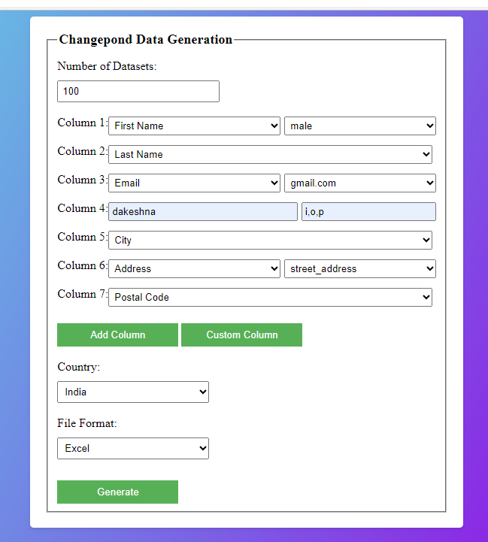

_____________________________END OF DOCUMENTATION_________________________ ______________